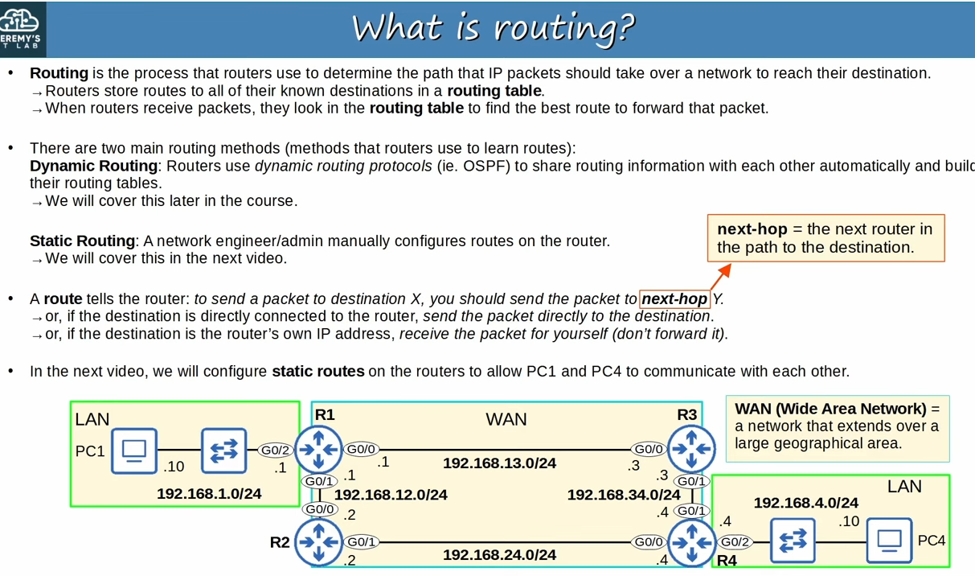
What is routing?

Note: (answer from chatgpt)In networking, a route refers to the path that data packets take from a source device to a destination device across a network.
Note: Answer to question of what is route, is in third point.
Note: Four routers together represent a WAN(definition in image). For example each of these four routers could be in different cities or even in different countries
Note WAN connection between R1 and R2 is 192.168.12.0/24.R1’s G0/1 IP is .1 and R2’s G0/0 IP is .2.(All the WAN connections between routers are alike this)
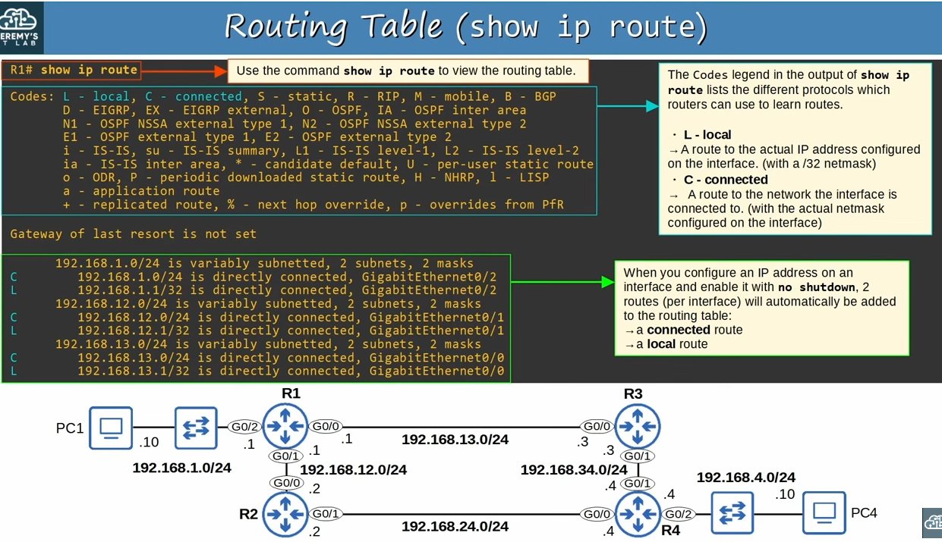
‘show ip route’ command(Displays router’s Routing table)

Note: L and C are just highlighted by Jeremy,not by ‘show ip route’ command.
Note: (in addition to explanation of Codes in the right top) As well as the codes that represent them in the routing table.
Note: L and C are examples of codes.
Note: There are three routes with L,and three with C,highlighted in blue.
Note: There are 2 types of routing dynamic routing and static routing.However,these connected and local routes are neither.They are simply added automatically,when an interface is configured.

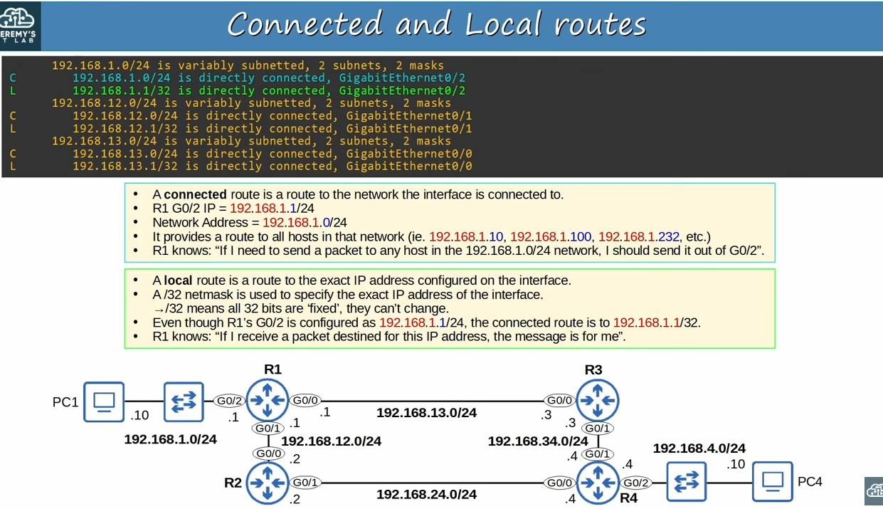
Explanation of two highlightes routes(Connected and Local route)
Note: in third point of connected route explanation network refers to 192.168.1.0/24.
Note: On the connected route there is written ‘192.16.1.0/24’ is directly connected,GigabitEthernet0/2’ So R1 knows if need to send any packet to any host in that network,i should send it out of G0/2.
Note:(in addtion to local route second point)Even though R1’s G02 is configured as 192.168.1.1/24,the local route is to .1/32.Which specifies only that address.It doesn’t include 192.168.1.2 or 192.168.1.5 for example.
Note:So with this local route R1 knows,if I receive a packet for this IP address,the message is for me’.
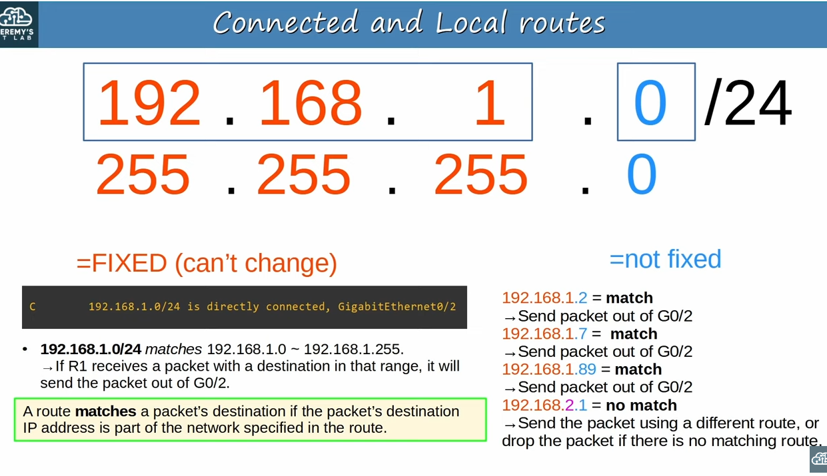

To make things clearer in local connected route
Note: In case when prefix length is 24,it means that that first bits are fixed,but last 8 bits are not fixed,they can be any number.So because of that, 192.168.1.0/24 matches 192.168.1.0 to 192.168.1.255.That means that if R1 receives a packet with destination in that range,it will send the packet out of G0/2.
Note: In the right for example 192.168.1.2 is a match,because the IP address begins with 192.168.1,because its /24,the first 3 octets have to match.
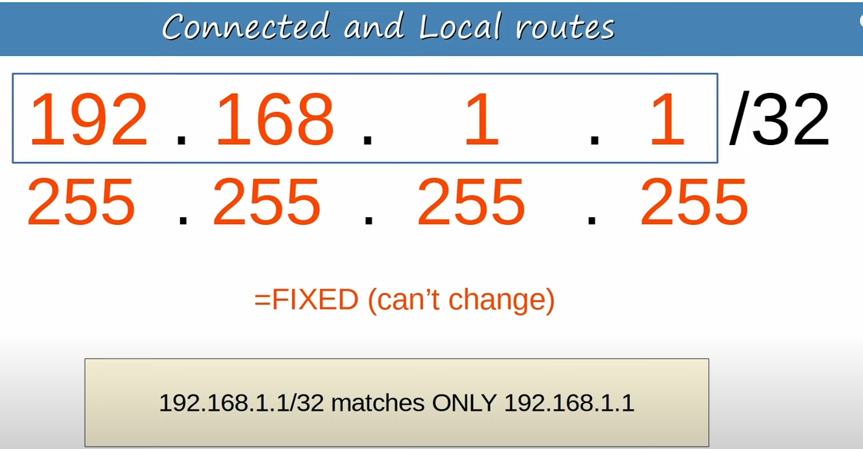
About /32
Note: Because in this IP address we use /32 it only matches 192.168.1.1 address.

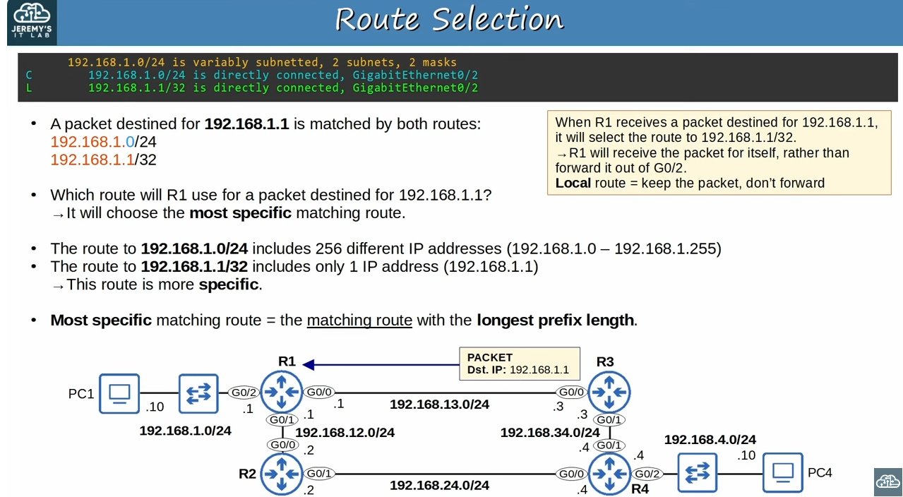
Route selection
Note:(in addittion to second point’s question) Will it send the packet out of G0/2(because of 192.168.1.0/24),or it will receive it(192.168.1.1/32)?
Note:From this we can understand the purpose of local route,they tell the router to keep the packet,don’t forward it.This means R1 will de-encapsulate and the packet and look at the contents inside,because the contents are addressed to R1 itself

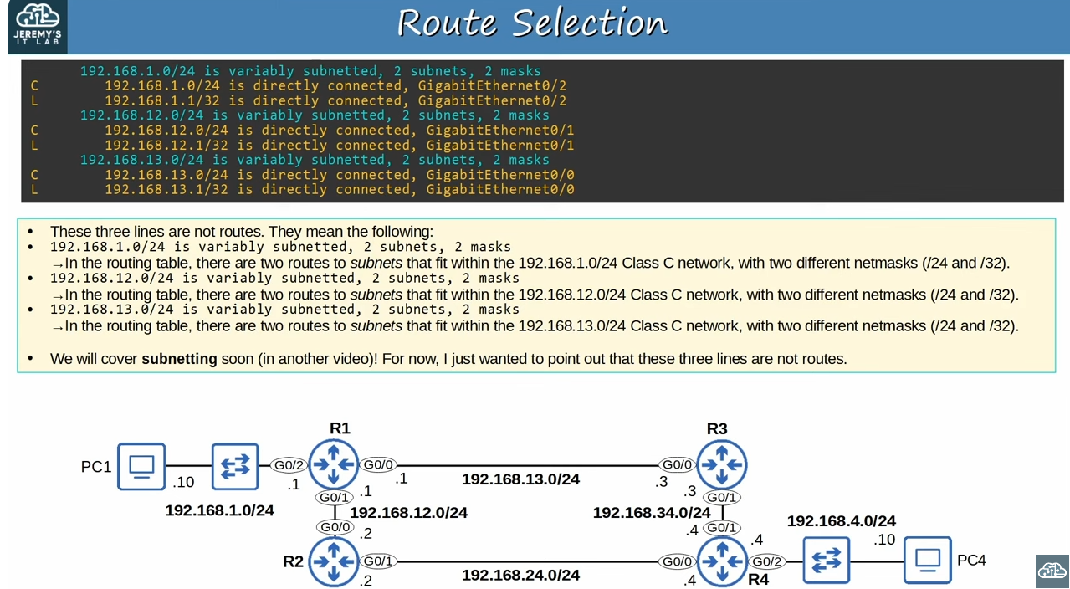
About highlighted lines(highlighted with blue on top)
Note: Highlighted lines are not routes.That lines will be covered in further .odt files.

